VPC -02
1.Create one VPC, with 1 public subnet and 1 private subnet.
First we should create VPC with particular CIDR range.
In that range we should create subnets.
CIDR range -192.168.0.0/24
Public subnet-192.168.0.1/26
Private subnet-192.168.0.65/26
Public subnet need to have internet access so we need to attach that to internet gateway.
Create route table for public subnet and attach to VPC and add that public route table to internet gateway .
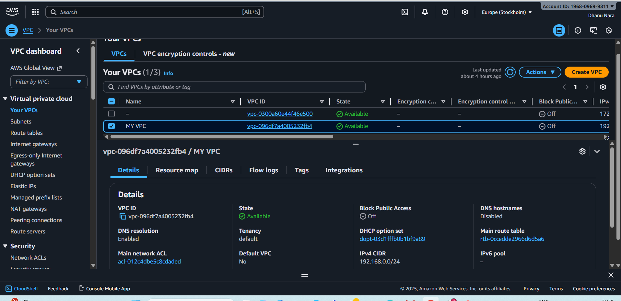
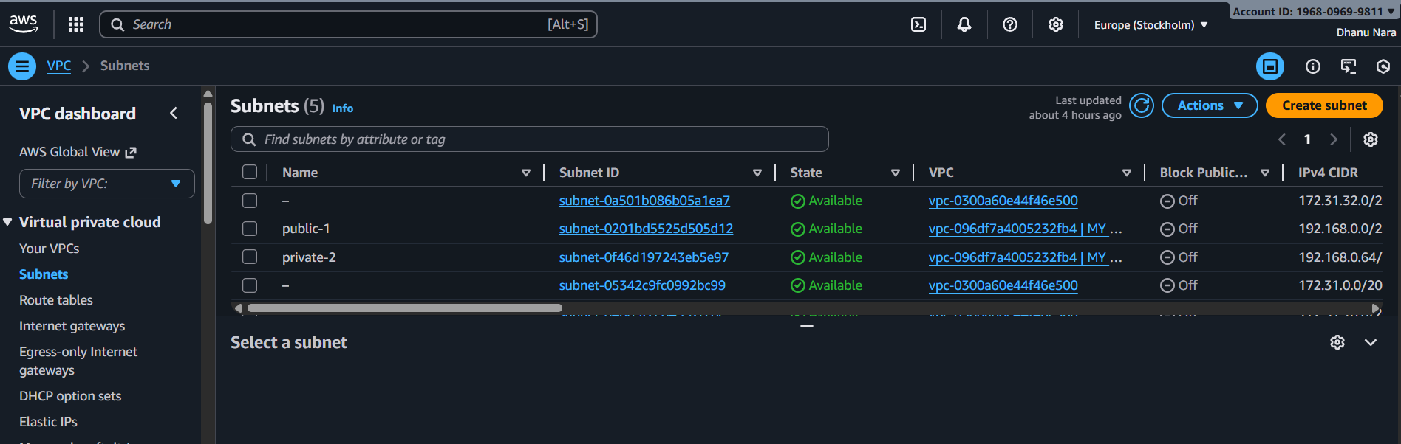
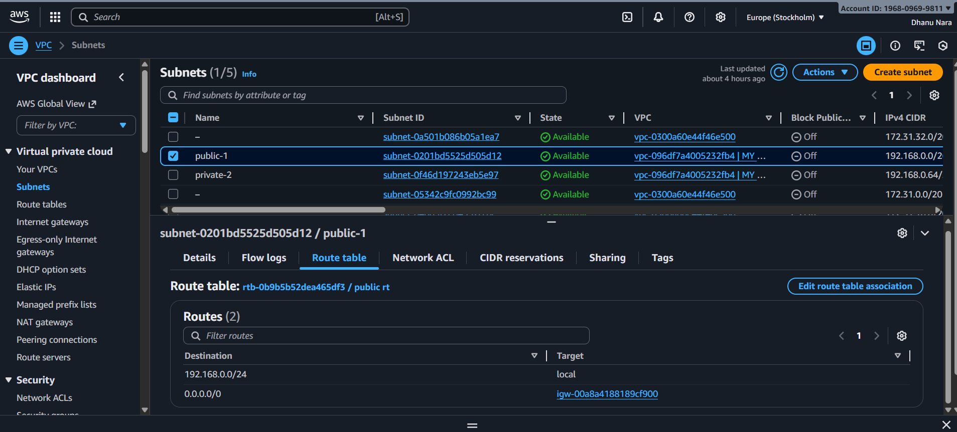
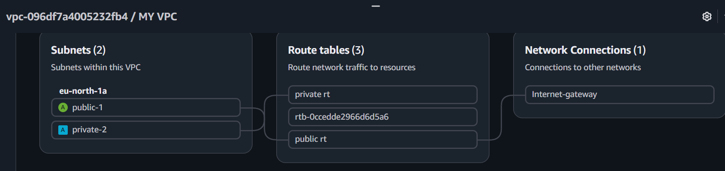
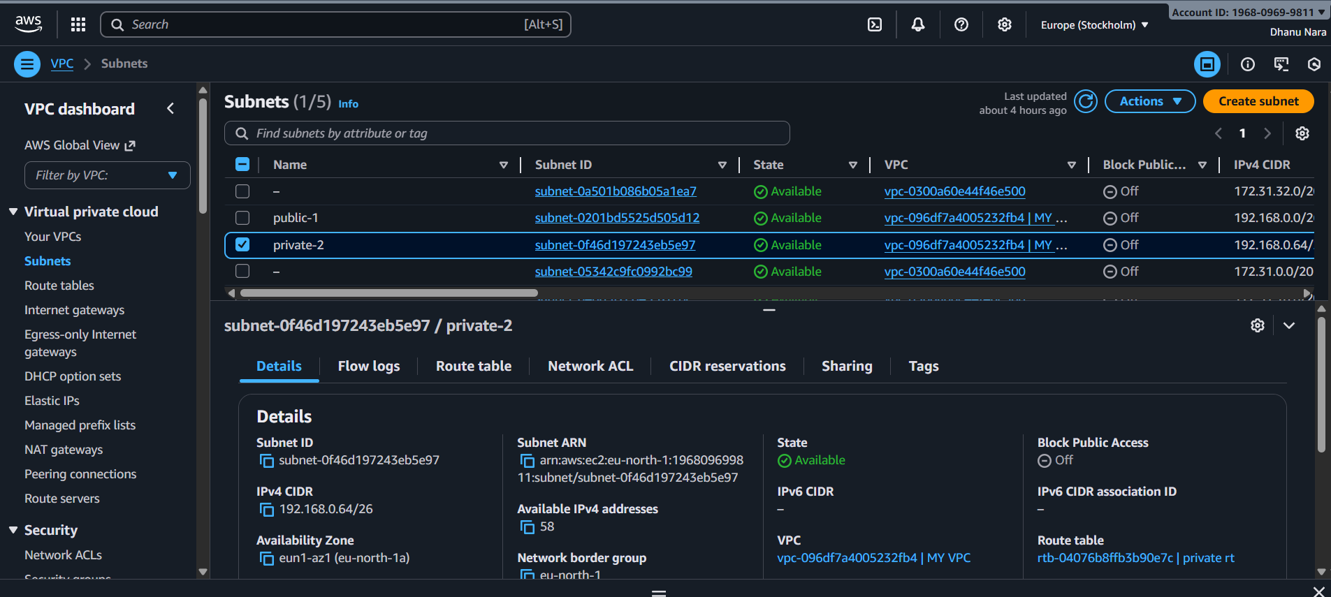

2.Enable VPC peering for cross-region.
We do VPC peering to establish a communication between two instances of same region or different regions.
First we should create one ec2 instance in one region.
Create one more ec2 in another region.
Now we should go to VPC and go to peering connections then create peering connection.
While connecting this IP addresses should not overlap.
Two regions instances will communicate automatically if both the instances are public.
Whereas if one instance of one region if we use public IP to connect another instance of that particular region if we use private IP thenwe can establish connection through peering.
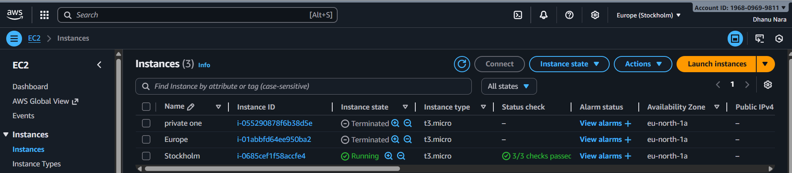
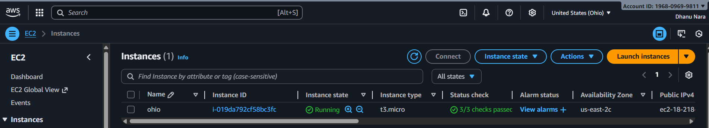
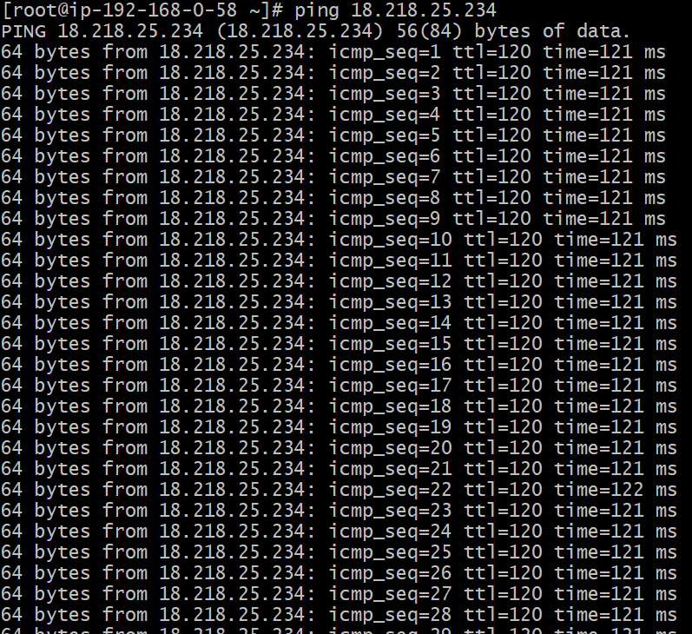
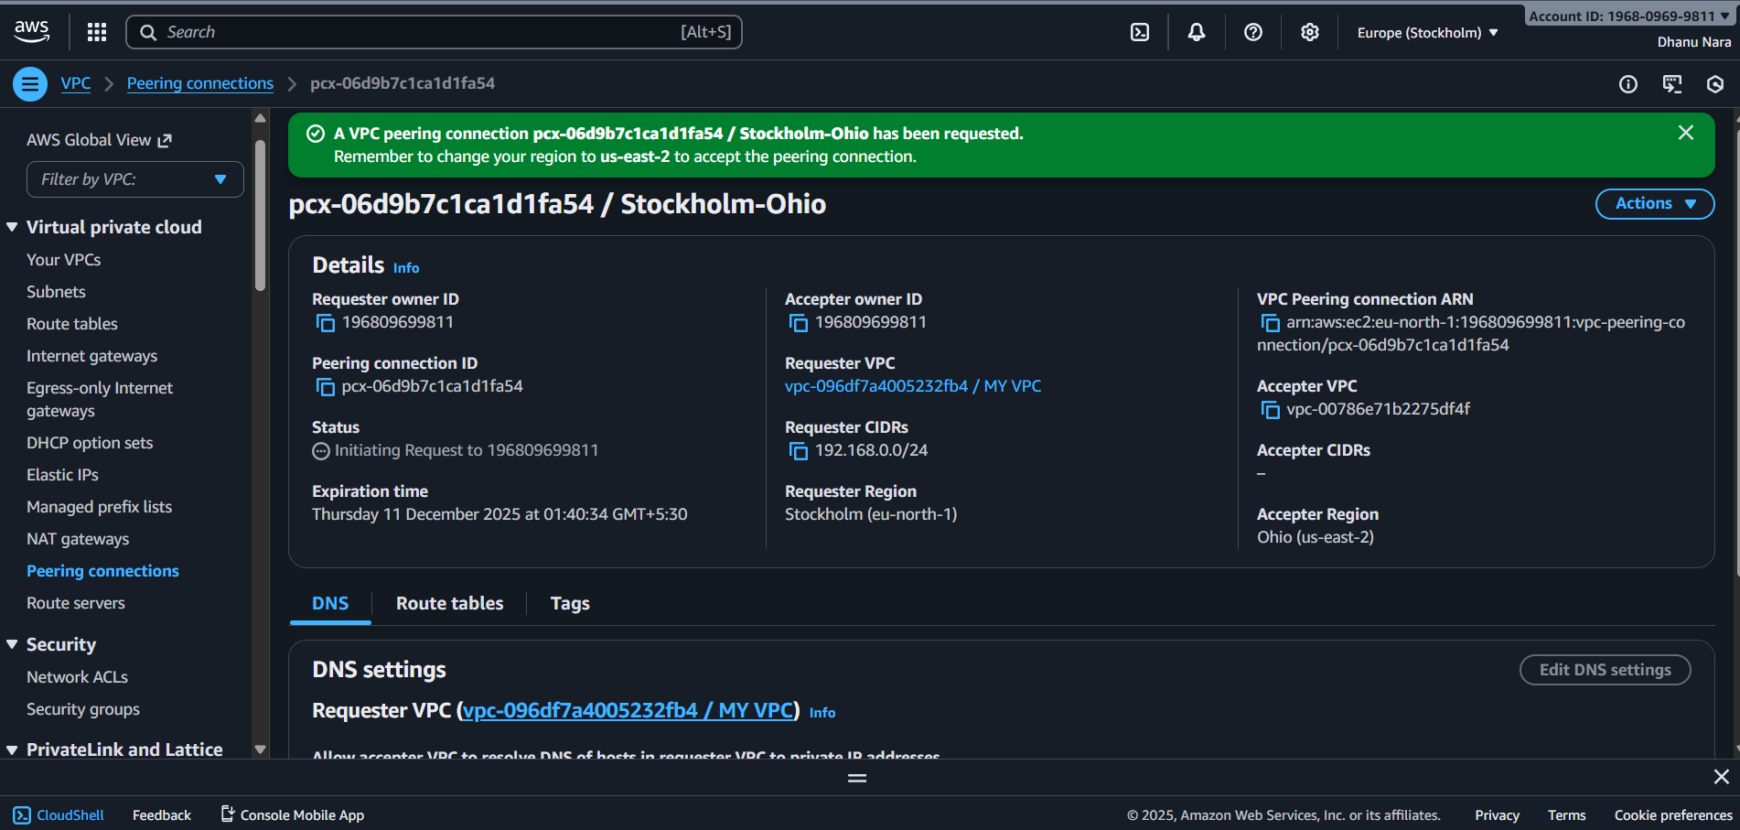

3.Enable cross peering for cross-account.
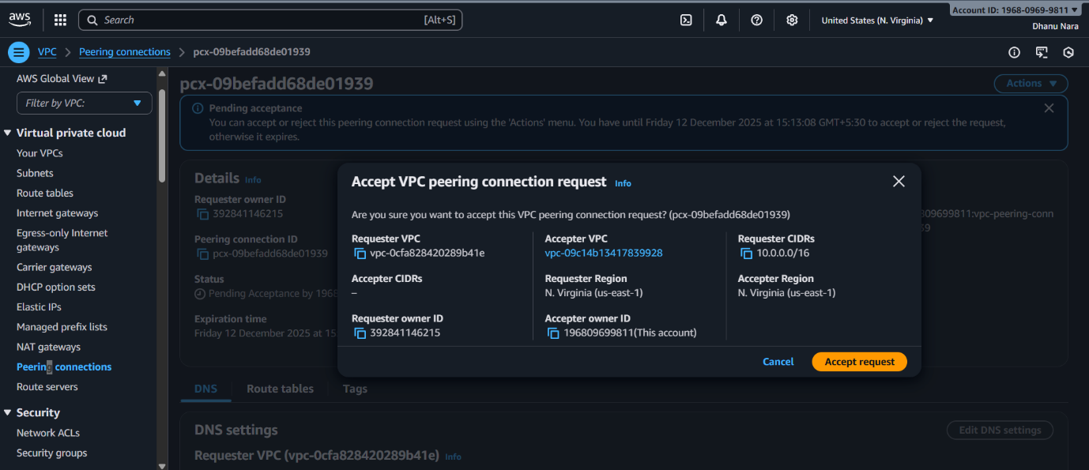
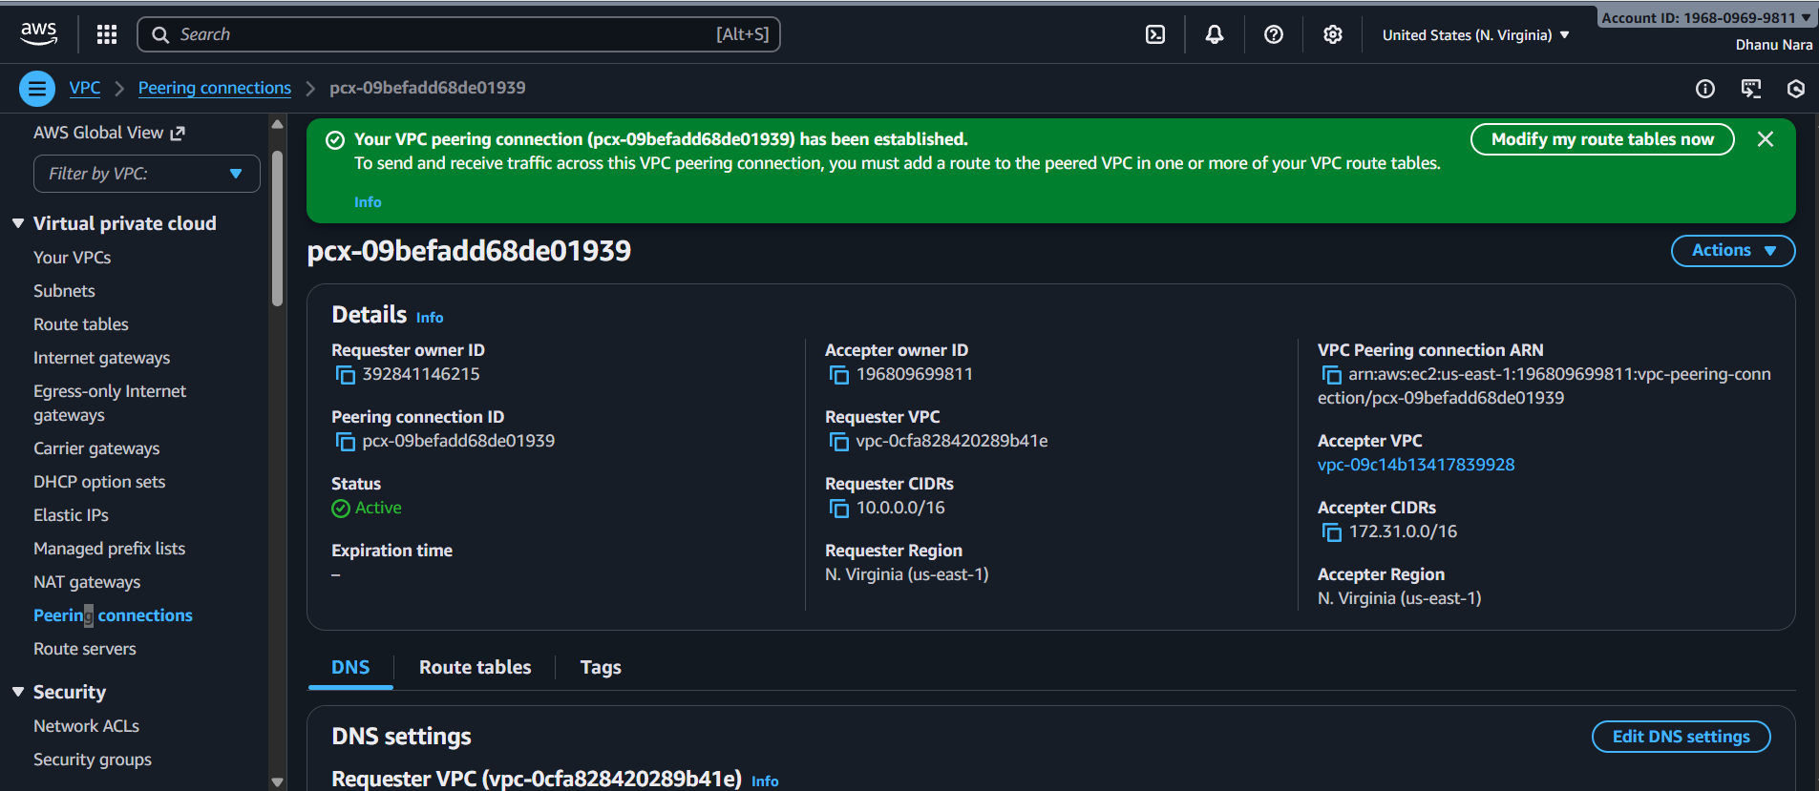
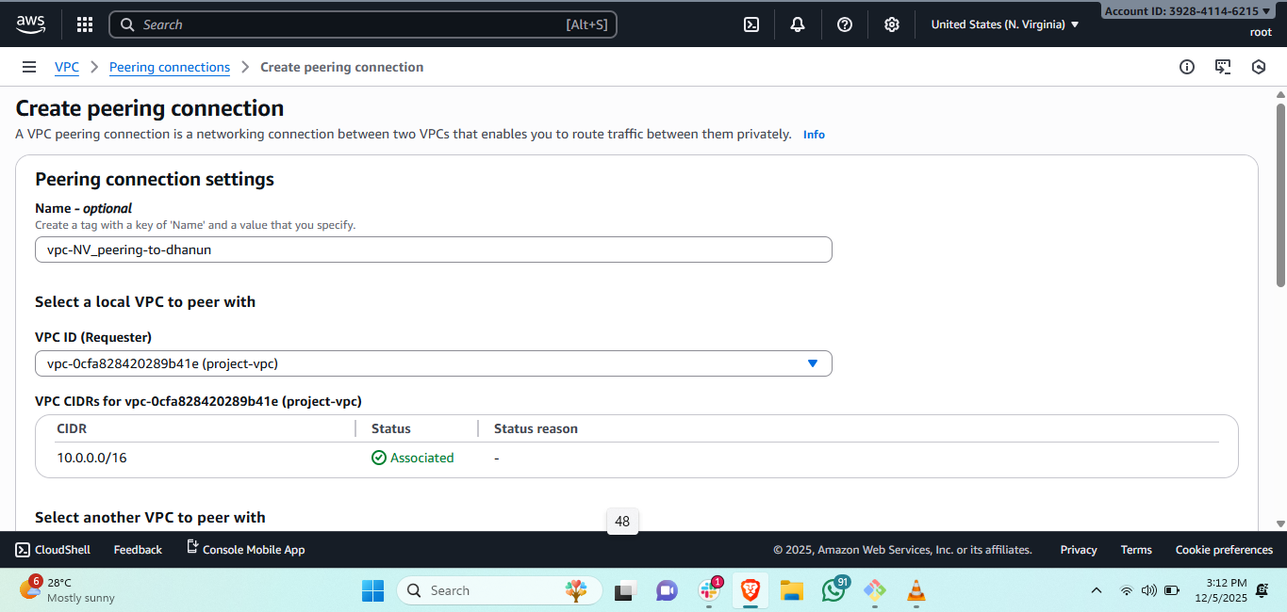
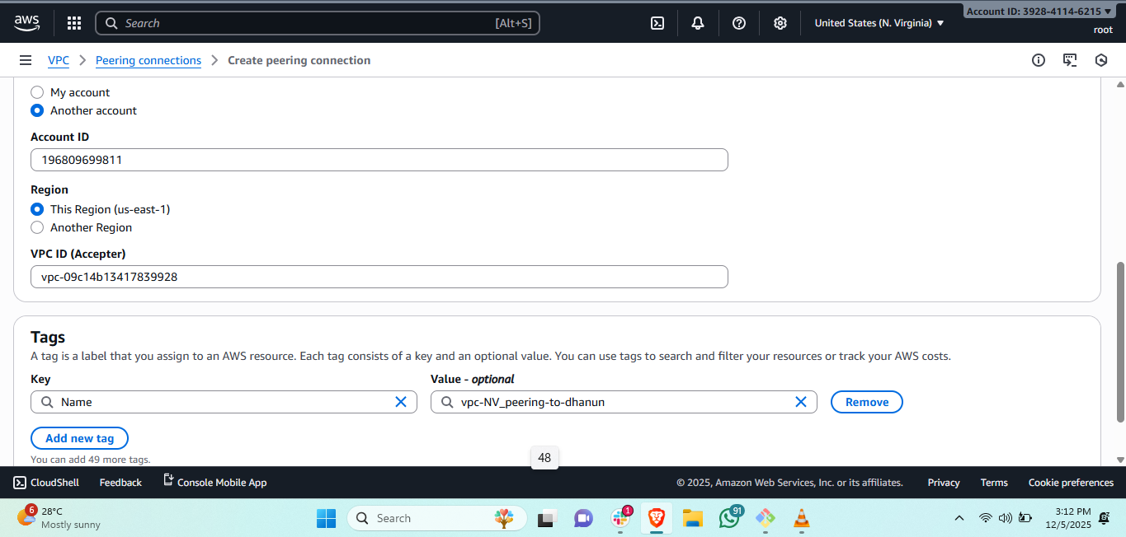
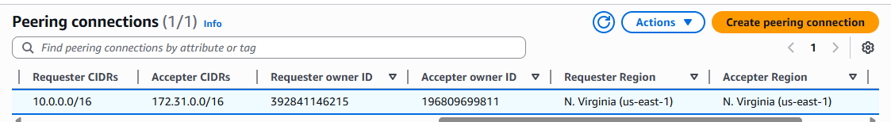
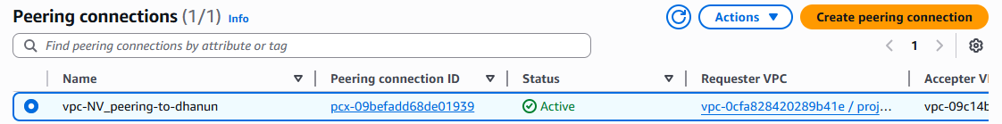

4.Set up a VPC Transit Gateway.
Transit gateway is used for connecting multiple VPCs.
We should first create multiple VPCs which we are going to connect.
And create the subnets and also the route tables.
Create one transit gateway along with that also create multiple transit gateway attachments.
Attach all the VPCs to the transit gateway and also add routes and attach all other IPs and the transit gateway attachments to that.
Now launch multiple instances for multiple VPCs separately and also add the subnets.
Now try to ping with other private IP instance it will connect.
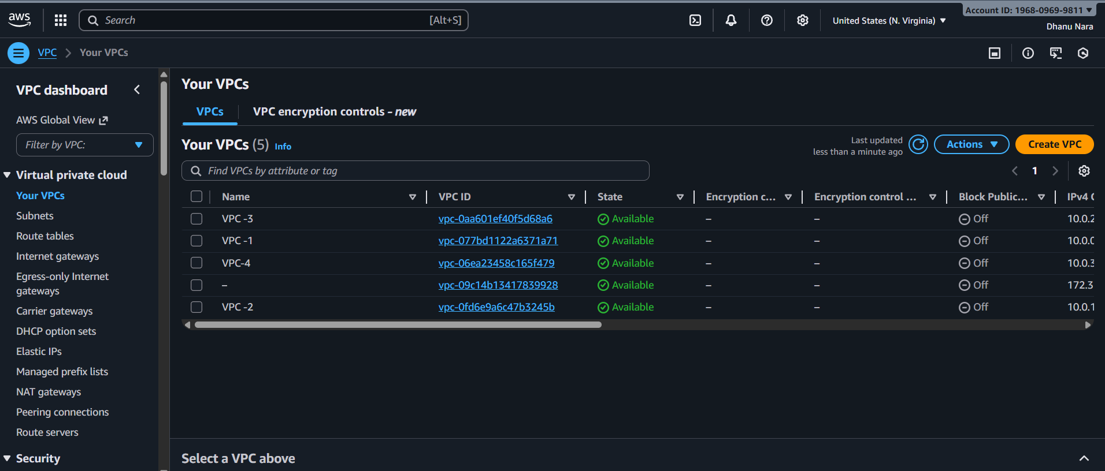

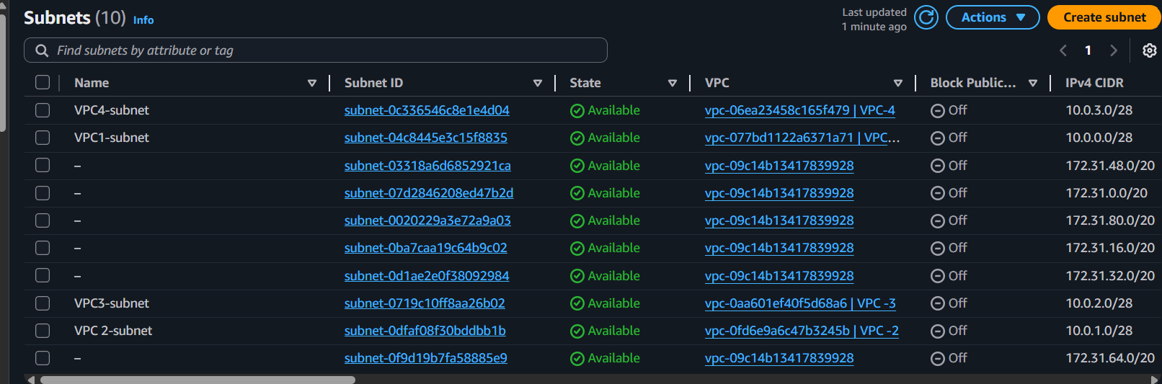

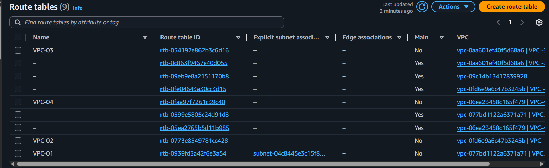
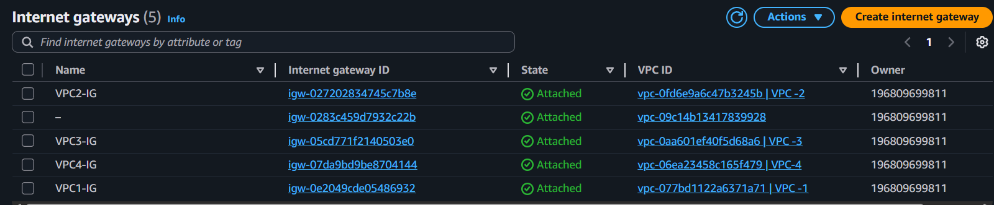
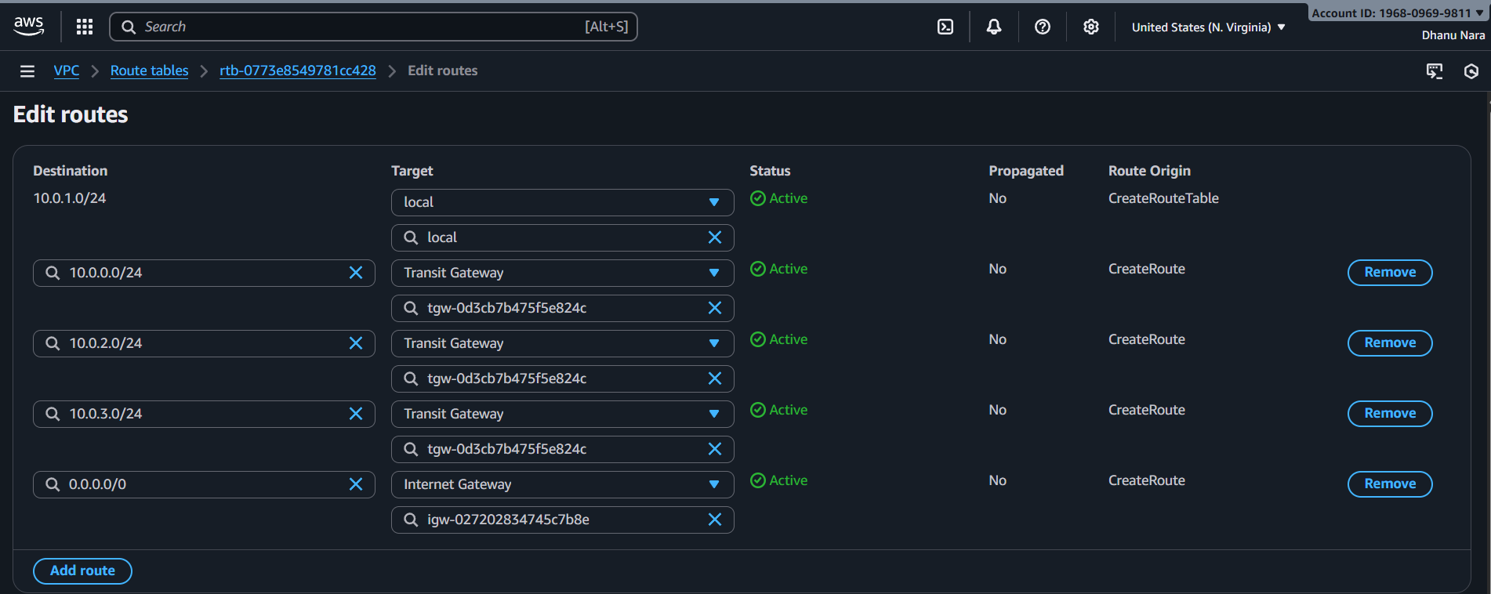
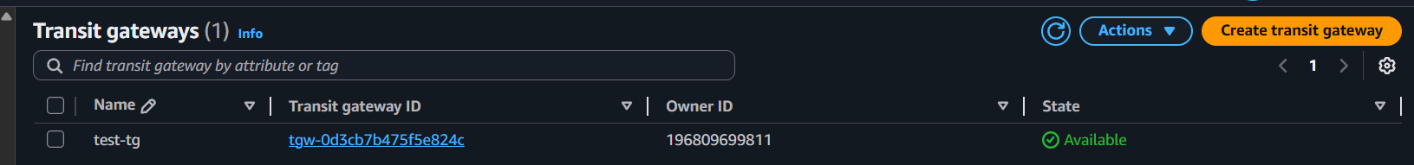
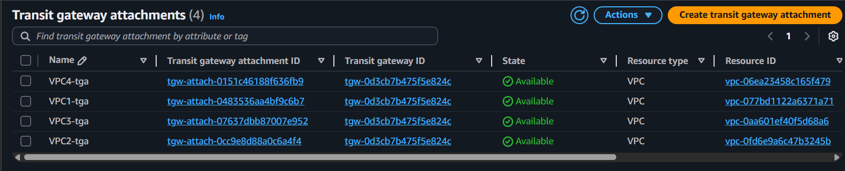

5.Set up a VPC endpoint.
A VPC Endpoint is like a private door from our VPC to AWS services.
Ec2 instance in a private subnet can reach AWS service privately, without internet.
We need this VPC Endpoint because private ec2 cannot reach like to s3 etc
We need NAT gateway to go to internet.
So we don’t need NAT with VPC Endpoint.

First we should create VPC
Public subnet and private subnet and also public and private route tables
And create two ec2 instances and connect first instance with public IP and check the communication.
Now connect to second instance of private IP using jump server now check the communication.
Create a end point and attach that endpoint to private route table.
Now communication will happen.
